COINS-Xian-Panticapaeum-Crimea-Bronze coin featuring the God Pan-4th c BCE

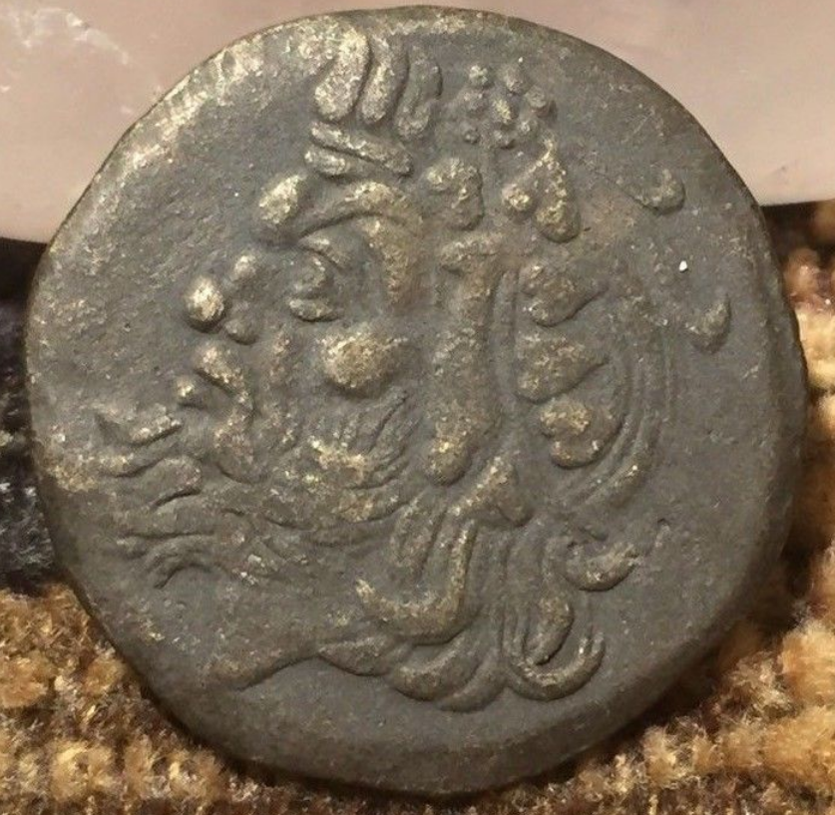 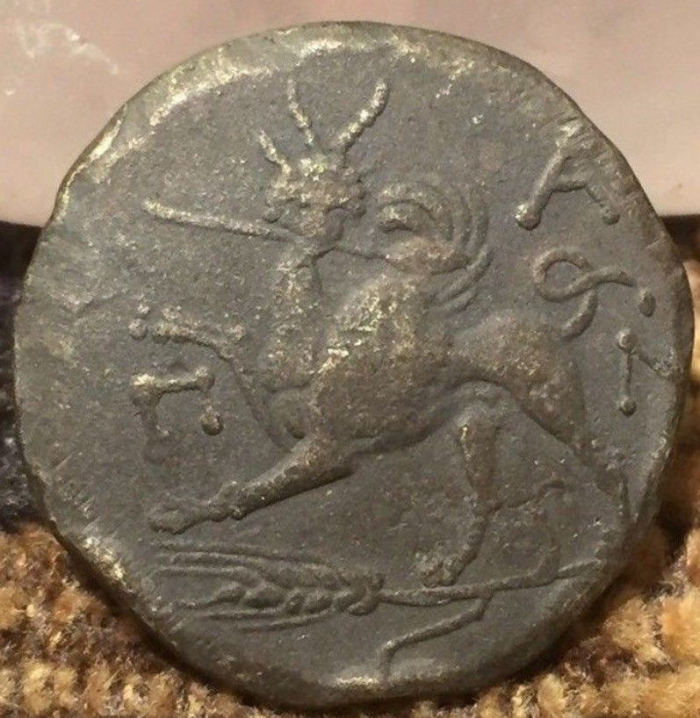

**Case no.:**

**Accession Number:**

**Formal Label:**

**Display Description:**

Pantikapaion, an ancient Greek city built on Mount Mithridat, a hill on the western side of the Cimmerian Bosporus, the eastern shore of Crimea, which the Greeks called Taurica.

Coin description: AV stater. ca. 350-300 BC., 9.12g. Head of bearded satyr facing three-quarters left, with long dishevelled hair and pointed horse’s ear / Rev. Π-A-N, winged griffin standing left, horned head facing, right forepaw raised, holding a spear in its jaws, large corn-ear below. Anokhin 97; Gulbenkian 583-584; Jameson 2143.

According to Pausanias, the Megarians said that their town owed its origin to Car, the son of Phoroneus, who built the citadel called 'Caria' and the temples of Demeter called Megara, from which the place derived its name (Paus. i. 39. § 5, i. 40. § 6). In fact, it was founded by Milesians in the late 7th or early 6th century BCE. The ruins of the site are now located in the modern city Kerch.

During the first centuries of the city's existence, imported Greek articles predominated: pottery (Kerch Style), terracottas, and metal objects, probably from workshops in Rhodes, Corinth, Samos, and Athens. Local production, imitated from the models, was carried on at the same time. Athens manufactured a special type of bowl for the city, known as Kerch ware. Local potters imitated the Hellenistic bowls known as the Gnathia style as well as relief wares—Megarian bowls.

The city minted silver coins from the 5th century BCE and gold and bronze coins from the 4th century BCE like this example (Sear 1978). At its greatest extent it occupied 100 hectares (250 acres).

**LC Classification: CJ277**

**Date or Time Horizon:** 4th century BCE

**Geographical Area:** Panticapaeum in the eastern Crimea

**Map:**

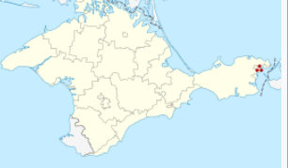

**GPS coordinates:** [45°21′3″N 36°28′7″E](https://tools.wmflabs.org/geohack/geohack.php?pagename=Panticapaeum&params=45_21_3_N_36_28_7_E_type:landmark)

**Cultural Affiliation:** Archaic Geek

**Medium:** bronze

**Dimensions:** 2 cm

**Weight: 6.2 gm**

**Condition: original**

**Provenance:**

**Discussion:**

Panticapaeum was the capital of the largest political state in the region of the ancient Black Sea –the Bosporan Kingdom. The archaological site has evidence of having been occupied by Greeks, Scythians, and Sarmatians. Panticapaeum was the site of the oldest Christian church in Ukraine, the tenth-century Church of St. John the Baptist. The site has been excavated since c 1780 and is unequalled in the Black Sea region for its artifacts, including coins, ceramics, jewelry and sculptures. The Hermitage and Kerch Museums contain material from the site, which is still being excavated

**References:**

Dittrich, K. 1963. *Ancient coins from Olbia and Panticapaeum* London: Spring Books,

Noonan, Thomas S. 1973. "The Origins of the Greek Colony at Panticapaeum," American Journal of Archaeology, **77** (1): 77–81.

Sear, David R. 1978. *Greek Coins and Their Values*. London: Seaby Ltd. Volume I: Europe (pp. 168-169).

Treister, Michail Ju. 1990. "A Matrix from Panticapaeum". *The Journal of the Walters Art Gallery*, 48: 29–35.

Tsetskhladze, Gocha R. 1997. "A Survey of the Major Urban Settlements in the Kimmerian Bosporos (With a Discussion of Their Status as Poleis)". In Nielsen, Thomas Heine. *Yet More Studies in the Ancient Greek Polis*. Historia Einzelschriften. 117. Stuttgart: Franz Steiner Verlag. pp. 39–82.